Lab 2: ER Model

Tailang Cao u1480633

**Part 1 - ER Diagram for Chess Database**

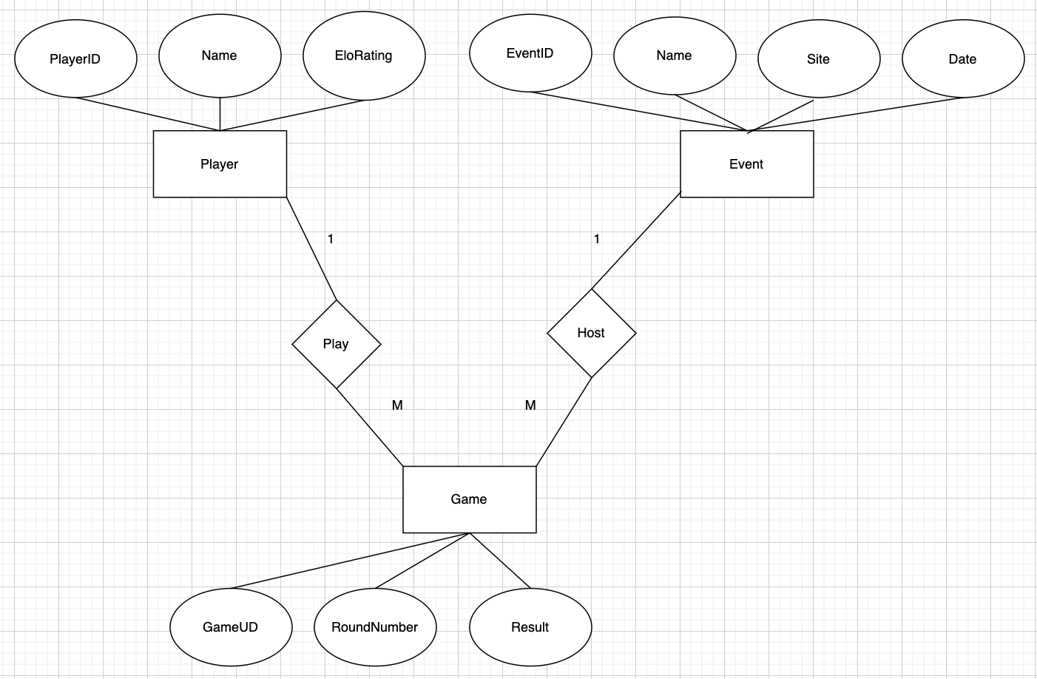

**Part 2: SQL Tables**

Schemas:

1. **Player**: Represents the player entity.

* PlayerID (Primary Key)
* Name
* EloRating

1. **Event**: Represents the event entity.

* EventID (Primary Key)
* Name
* Site
* Date

1. **Game**: Represents the game entity.

* GameID (Primary Key)
* RoundNumber
* Result

1. **Play**: Represents the many-to-many relationship between Player and Game.

* PlayerID (Foreign Key)
* GameID (Foreign Key)

1. **Host**: Represents the many-to-many relationship between Event and Game.

* EventID (Foreign Key)
* GameID (Foreign Key)

SQL Commands:

-- Create Player table

CREATE TABLE Player (

PlayerID INT PRIMARY KEY,

Name VARCHAR(255) NOT NULL,

EloRating INT

);

-- Create Event table

CREATE TABLE Event (

EventID INT PRIMARY KEY,

Name VARCHAR(255) NOT NULL,

Site VARCHAR(255),

Date DATE

);

-- Create Game table

CREATE TABLE Game (

GameID INT PRIMARY KEY,

RoundNumber INT NOT NULL,

Result VARCHAR(50)

);

-- Create Play table (many-to-many relationship between Player and Game)

CREATE TABLE Play (

PlayerID INT,

GameID INT,

PRIMARY KEY (PlayerID, GameID),

FOREIGN KEY (PlayerID) REFERENCES Player(PlayerID),

FOREIGN KEY (GameID) REFERENCES Game(GameID)

);

-- Create Host table (many-to-many relationship between Event and Game)

CREATE TABLE Host (

EventID INT,

GameID INT,

PRIMARY KEY (EventID, GameID),

FOREIGN KEY (EventID) REFERENCES Event(EventID),

FOREIGN KEY (GameID) REFERENCES Game(GameID)

);